Use Cases (Iteration 2)
URL for WIKI page: https://github.com/ImadeddinOuahidi/GDP-Group5/wiki/Use-Cases-(Iteration-2)

Use Case 1: Submit an ADR Report
Goal: Patient submits a side effect report.
Actor: Patient
Inputs:
- Text description of side effect.
System Actions:
- Validate the input.
- Store the report securely in the database.
- Run severity analysis on the report.
Outputs:
- Confirmation message to the patient.
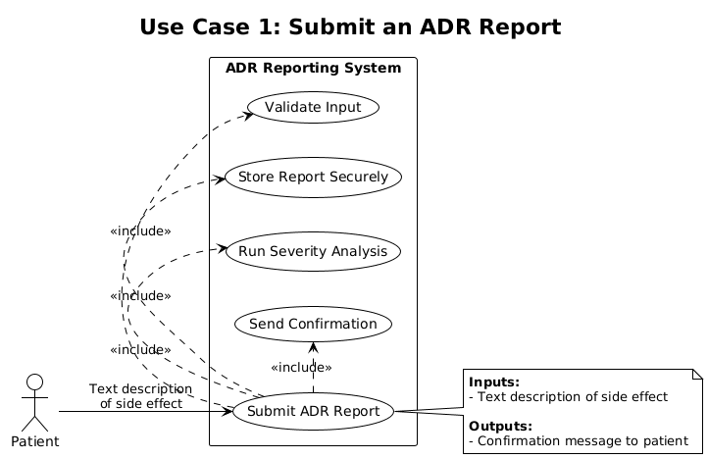

Use Case 2: Submit a Side Effect Report via Voice
Goal: Patient submits a side effect report using voice.
Actor: Patient
Inputs:
- Voice recording of the side effect.
System Actions:
- Transcribe audio to text.
- Save the transcription securely in the database.
- Run severity analysis on the transcription.
Outputs:
- Confirmation message to the patient.
- If the audio is unclear, the system prompts the patient to re-record.
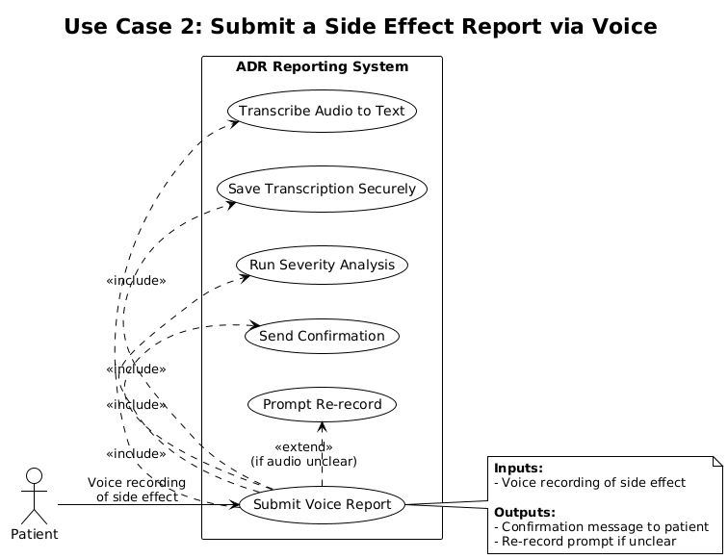

Use Case 3: Submit a Side Effect Report with Photo
Goal: Patient submits a side effect report using a photo.
Actor: Patient
Inputs:
- Photo or image showing the side effect (e.g., rash, swelling).
System Actions:
- Validate and securely upload the image.
- Store the image in the database linked to the report.
- Run AI analysis on the image and attach findings to the report.
Outputs:
- Confirmation message to the patient.
- If the image format/quality is invalid, the system prompts the patient to re-upload.
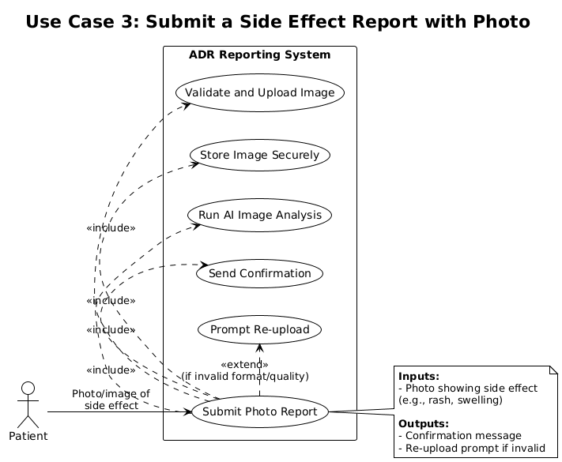

Use Case 4: Review ADR Reports
Goal: Healthcare staff reviews submitted ADR reports.
Actor: Healthcare Staff
Inputs:
- Search or filter request (e.g., by severity, date, or drug name).
System Actions:
- Authenticate staff login.
- Retrieve and display relevant ADR reports.
- Highlight any reports flagged as urgent or duplicates.
Outputs:
- Reports displayed to staff for review.
- Staff can take further action (confirm duplicates, prioritize urgent cases).
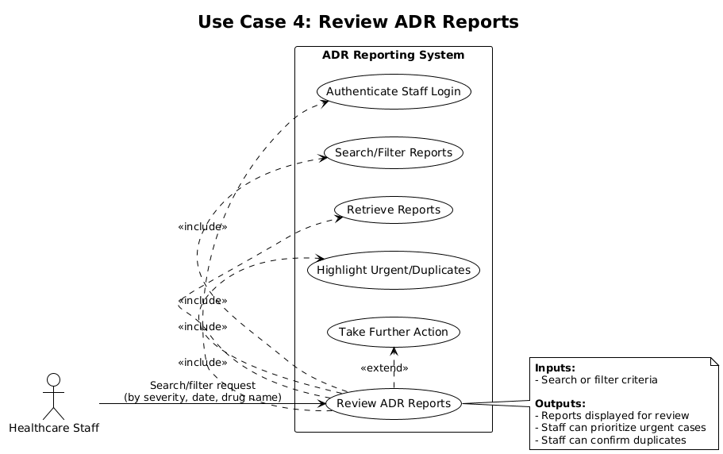

Use Case 5: Validate Submitted Report
Goal: System ensures required fields are filled.
Actor: System
Inputs:
- Patient-submitted form (text, image, or voice).
System Actions:
- Check all mandatory fields.
- Flag missing or invalid inputs.
Outputs:
- Error message if incomplete.
- Continue processing if valid.
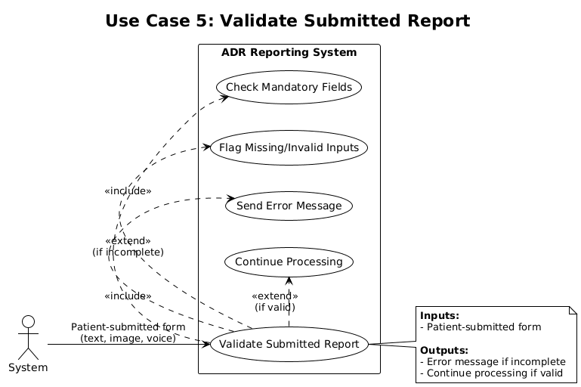

Use Case 6: Securely Store ADR Reports
Goal: System securely saves patient reports.
Actor: System
Inputs:
- Completed patient report (validated).
System Actions:
- Store report in encrypted database.
- Backup data automatically.
Outputs:
- Report stored with unique ID and timestamp.
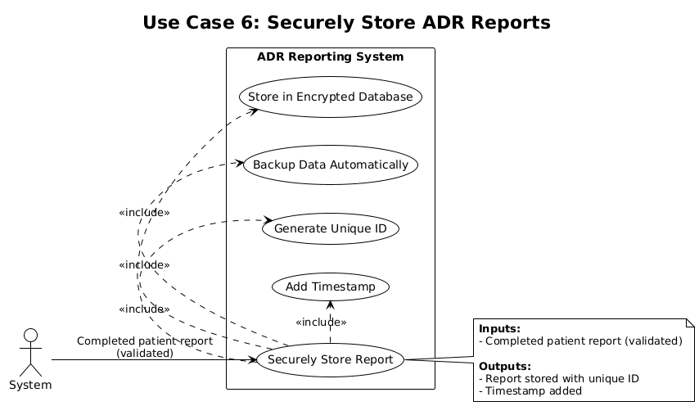

Use Case 7: Healthcare Staff Login
Goal: Staff securely access the system.
Actor: Healthcare Staff
Inputs:
- Username and password.
System Actions:
- Validate credentials against database.
- Restrict unauthorized access.
Outputs:
- Access granted to dashboard or access denied with error if invalid.
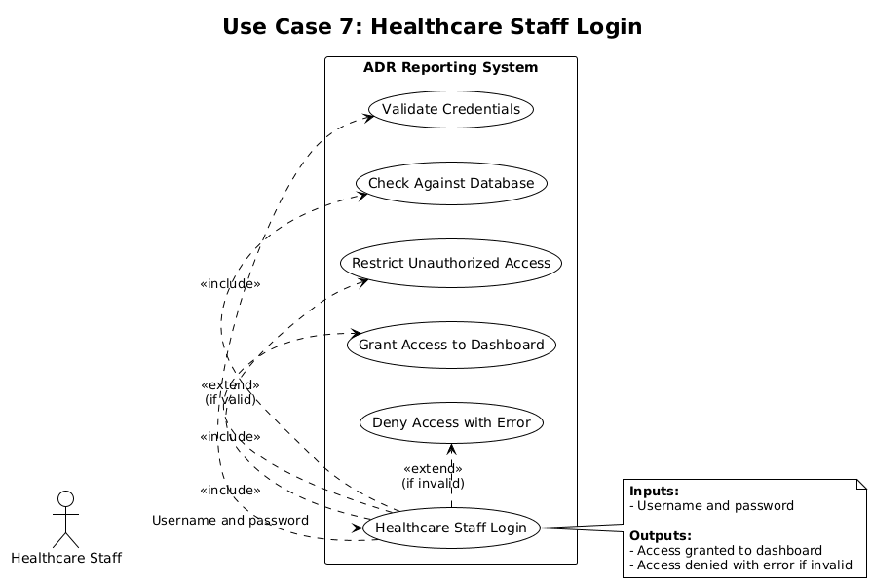

Use Case 8: Identify Duplicate Reports
Goal: System flags repeated reports.
Actor: System
Inputs:
- New patient report.
System Actions:
- Compare report with stored reports.
- Flag potential duplicates.
Outputs:
- Duplicates for staff review.
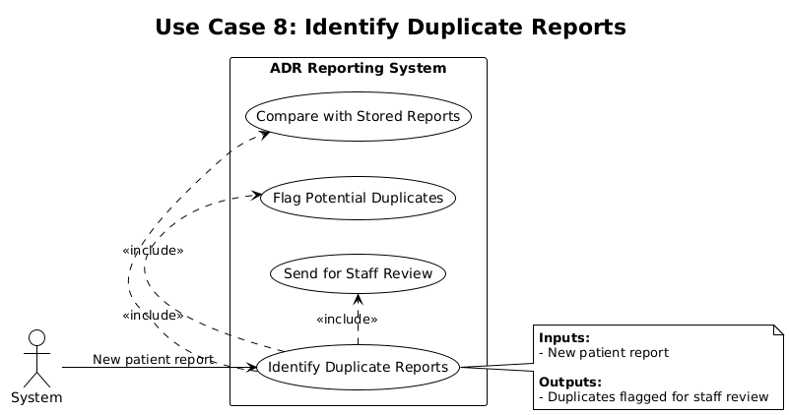

Use Case 9: Mark Report Severity
Goal: System assigns severity to each report.
Actor: System
Inputs:
- New report (validated and stored).
System Actions:
- Analyze content.
- Assign severity: Critical, High, Medium, Low.
Outputs:
- Severity stored with report.
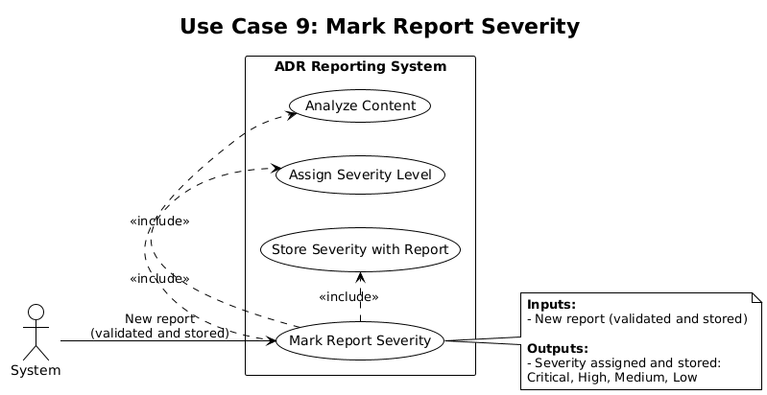

Use Case 10: Secure Upload of Reports
Goal: System handles different report formats securely.
Actor: Patient
Inputs:
- Text report, photo, or voice file.
System Actions:
- Encrypt during upload.
- Validate format and size.
Outputs:
- Confirmation of secure upload.
- Error if format or size are invalid.
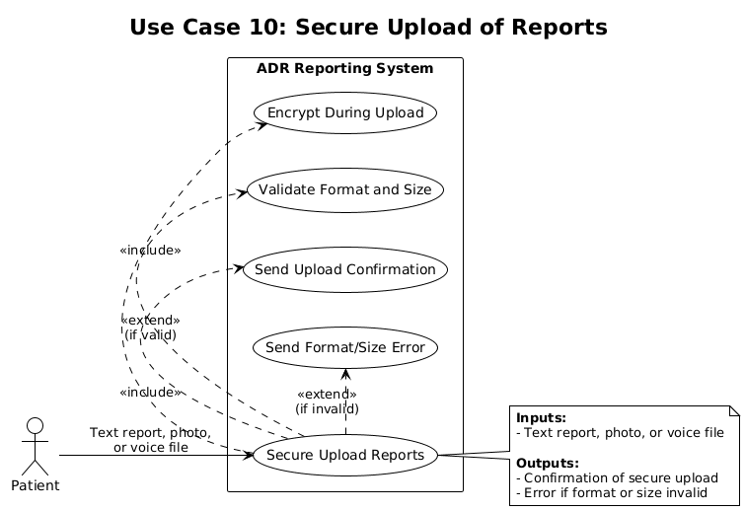

Use Case 11: Role-Based Access
Goal: Ensure different roles (Patient, Doctor) have different permissions.
Actor: System
Inputs:
- User credentials.
System Actions:
- Identify role after login.
Outputs:
- Patient: Submit and view own reports.
- Doctor: Review reports.
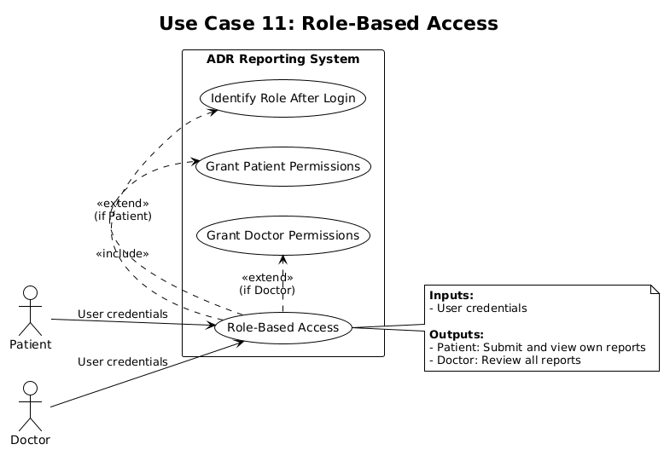

Use Case 12: Display Error Messages
Goal: Inform patients or staff when validation fails.
Actor: System
Inputs:
- Invalid or incomplete input.
System Actions:
- Detect error.
- Display meaningful error message.
Outputs:
- Error message shown.
- User prompted to fix input.
